**Data Visualization Using Tableau - 2**

**Assignment – 1**

**Sample Super Store**

**Report**

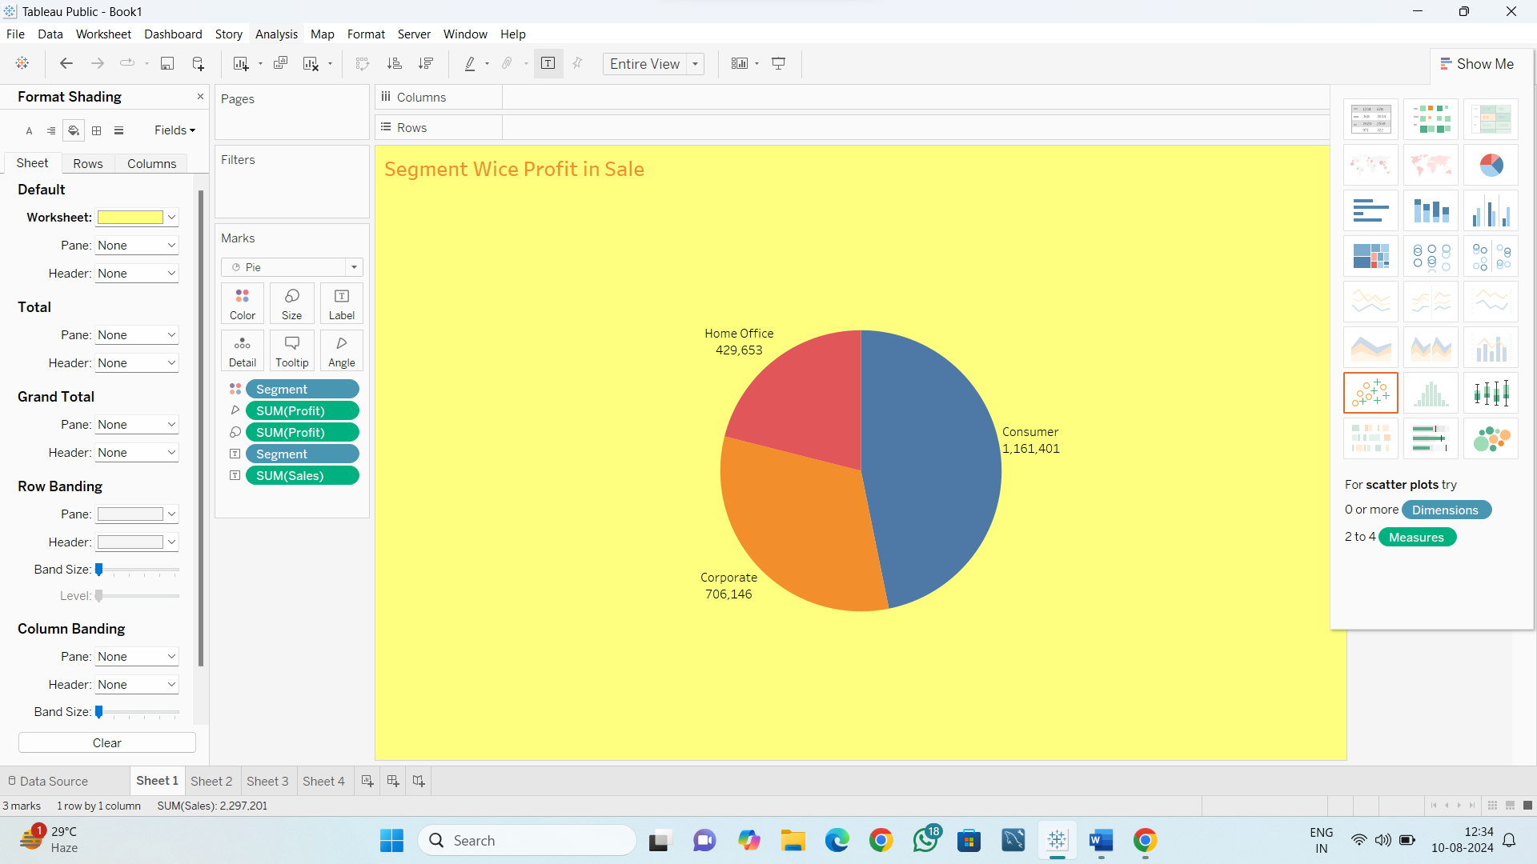

**Dashboard**

